SETTING UP ENVIRONMENT INSTALL IBM CLOUD CLI

|  |  |
| --- | --- |
| Team ID | PNT2022TMID17805 |
| Project Name | Customer Care Registry |
| Team Members | Abishek L, Athista Lakshmi ,  Bala Murugan G, Harshini |

**Step 1:**To start with IBM cloud installation check the official website : <https://cloud.ibm.com/docs/cli?topic=cli-install-ibmcloud-cli>

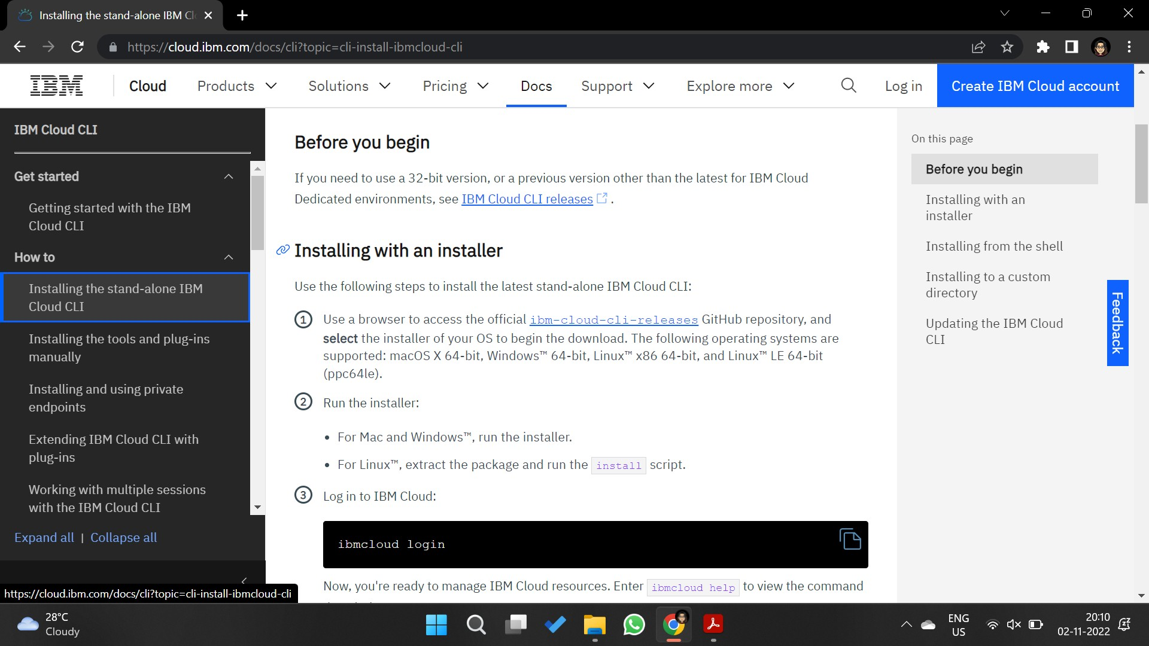

**Step 2:**Move forward to the git link specified in the installation guide

<https://github.com/IBM-Cloud/ibm-cloud-cli-release/releases/> and select the suitable link to download the setup according to the system configuration.

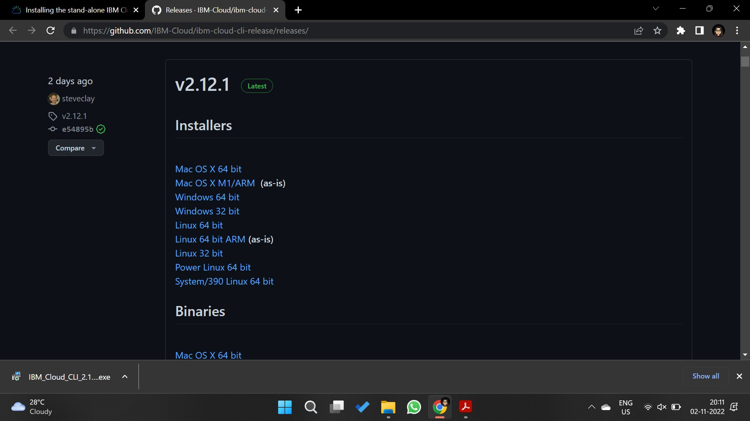

**Step 3:**Once the setup is installed, run it.

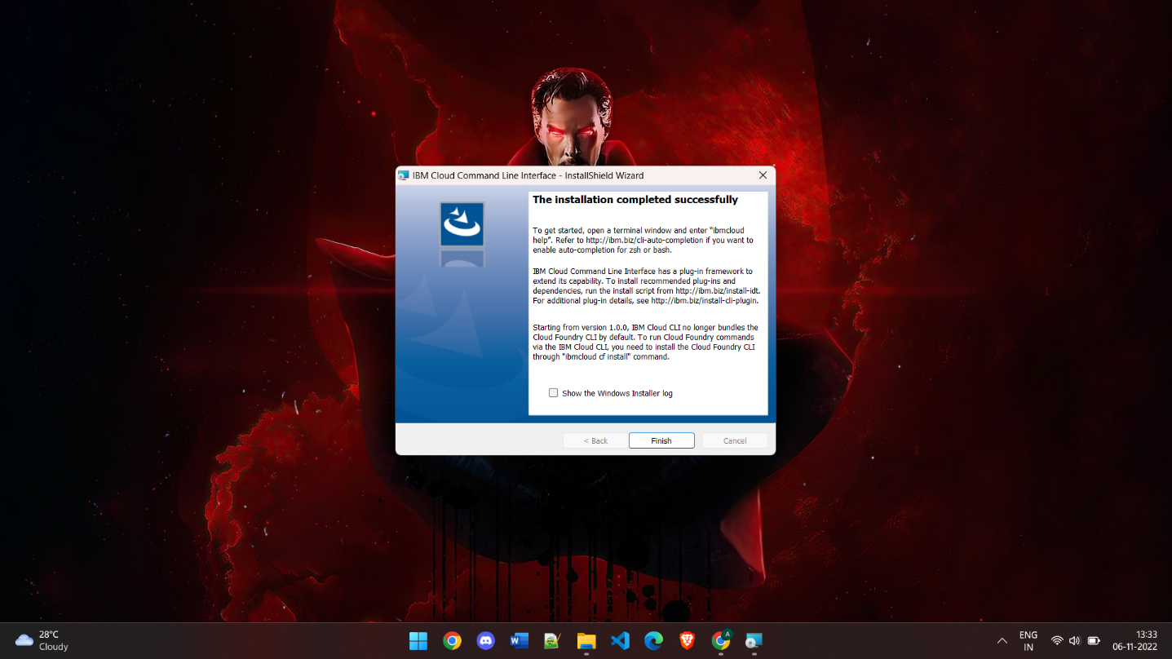

**Step 4:**Now go to the command prompt and check if the IBM Cloud CLI is installed properly and along with it check for the updates.

For version check: **ibmcloud -v**

For update check: **ibmcloud update**

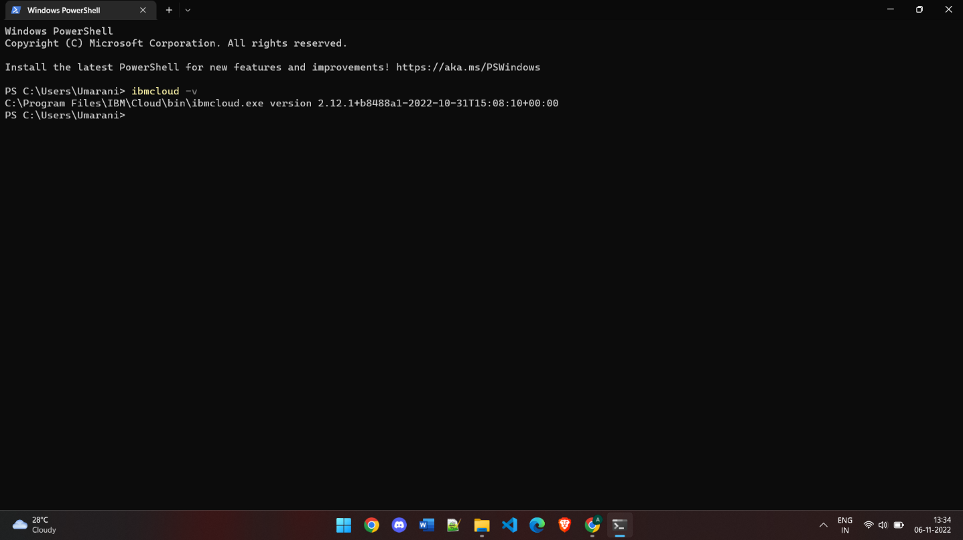

**Step 5:**Use the IBM login credentials to successfully finish the IBM Cloud CLI installation and use the IBM CLI guide on the official websites for any plugin installations.

To Login: **ibmcloud login**

